October 2026 | View this in your browser

  Sorted!  Waste news | 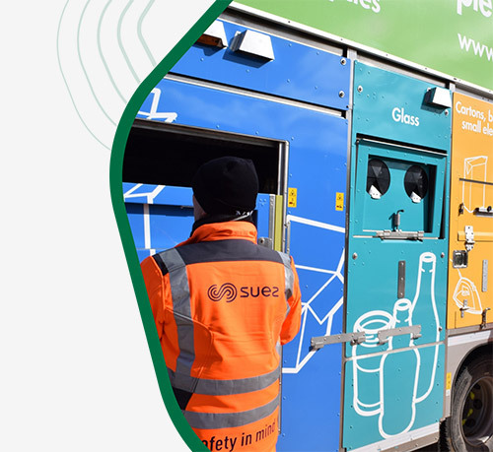

Latest news

Autumn and winter opening times have begun at recycling sites
Recycling Sites are now open from 9am to 5pm on weekdays and from 9am to 4pm at weekends.
Midweek, opening days vary between sites however all sites are open on Saturdays and Sundays.
The autumn and winter timetable applies until 31 March 2027.

Recycling sites

Top reuse stats celebrated as latest Recycling Tracker launched
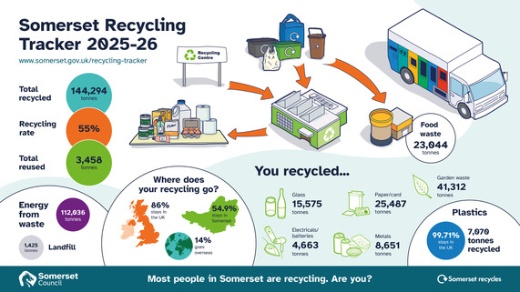
Our latest recycling tracker has been published, and this year showed that we have all been reusing more. With nearly 3,500 tonnes of materials recorded as being passed on for reuse (an increase of 26% from 2,700 tonnes last year).
Take a look

Somerset residents recycle more food waste
Well done to our residents, together we recycled 7.3% more food waste between July 2025 and July 2026 following a year-long campaign.
With more being recycled, the increase is equal to every household recycling an extra half a kitchen caddy every month.

Read more

Reuse

A Halloween without the horror of waste

When you are choosing a pumpkin, a smaller pumpkin is easier to carry, carve, cook and store, and you are much more likely to use it all.
The biggest pumpkin in the pile may look impressive, but it can leave you with more food than your household can finish. This Halloween, make one small change: choose a pumpkin that matches your plans and your appetite.
Find out more

Before the festive rush, make time for a fix
Although a couple months away, now is the perfect time to check if you can repair items before buying replacements for Christmas. Repairing fairy lights, toys, small electricals, clothes and household items can save money, keep useful materials in use and avoid adding to the festive waste pile.
Somerset has a network of volunteer-run repair groups where skilled repairers share practical advice and may be able to help bring broken items back to life. Skills and accepted items vary, so contact the group before travelling.

Find a group

Get it sorted!

Having a clear-out? Choose a registered waste carrier
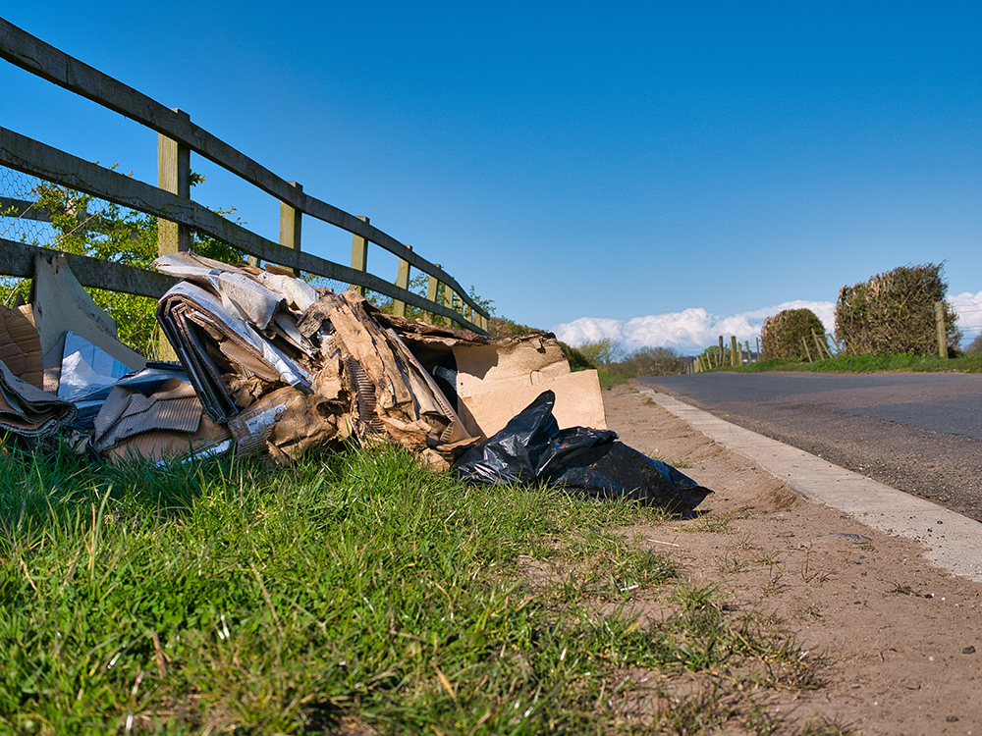
Having a clear-out or getting work done at home? If you pay someone to take away rubbish, old furniture, appliances or building waste, you have a legal duty of care to check that they are authorised to carry it. This applies whether you find them online, through social media or by recommendation.
If your waste is later fly-tipped and traced back to you, you could face enforcement action if you cannot show that you took reasonable steps to use an authorised person. A cheap quote is not worth the risk.

Before handing over your waste:
- Ask for the person or business name and waste carrier registration number.
- Check the details on the Environment Agency’s public register of waste carriers, brokers and dealers. For a business collecting other people’s waste, look for a current upper-tier registration.
- Make sure the name and address on the register match the person or business you are using. Do not rely on a photograph of a certificate alone.
- Ask where your waste will be taken and request a Waste Transfer Note that shows what was collected, the date and the carrier’s details.
- Keep the receipt, registration details and any messages or adverts.

Be cautious if someone will not provide their registration details, cannot explain where the waste is going, offers an unusually low cash-only price or asks to collect waste without giving a receipt.
If you see dumped waste, do not touch it or confront anyone. Note the location and any useful details, then report it through Somerset Council’s ‘Report fly-tipping’ service.

You can help to avoid a battery fire
Battery fires are on the rise, and they can be so easy to avoid. Since January 2026, there have been eight fires at Somerset waste facilities or on collection vehicles, with four caused by incorrectly disposed batteries and vapes. These items can be damaged during collection and processing, causing them to overheat and ignite.
Lithium-ion batteries are commonly found in everyday items such as mobile phones, laptops, power tools, toys and e-bikes.
- Never place loose batteries or electrical items, including those containing batteries in general waste bins.
- Use designated battery and vape recycling points, often available in supermarkets, or place them in a small, clear tied bag and leave on top of recycling boxes for kerbside collection.
- Take unwanted electrical items to local recycling centres.
- Small electrical items (excluding monitors, TVs or microwaves) can be collected from the kerbside, they should be left in carrier bags for collection.
- Residents can use the online lookup at recycleyourelectricals.org.uk for your nearest battery and electrical drop-off points.
For more information on safely recycling lithium-ion batteries and electrical items, visit our Waste pages.

Reasons to recycle
We all get recycling, but do you know why it's worth it?
Every item rescued from the rubbish bin helps save valuable materials and supports our efforts to reduce waste. Take a second look before you throw something in the bin – it might be ready for a new life instead.

Why recycle?
- Recycling a plastic bottle uses just 12% of the energy needed to make it from scratch.
- Recycling stops greenhouse gases like methane going into the atmosphere.
- Recycling helps keep valuable materials in circulation.

Join the Community Resilience Day 2026
Are you involved with a parish, town or city council, or a local community group? Join this free event to learn more about preparing your community for emergencies.
The day will include practical workshops, opportunities to meet others and demonstrations of useful equipment. The Somerset Prepared Community Resilience Day is organised by the Somerset Prepared Partnership and funded by Somerset Rivers Authority.
Somerset Prepared brings organisations and communities together, offering advice, guidance, support and training to help local areas prepare for, respond to and recover from emergencies. For simple tips on staying safe at home, in your community and at work, visit the Somerset Prepared website.



